Article Title: UK Inflation hits 30-year high of 7%

Key Concept: Intervention

Source: CNN Business

URL: <https://www.cnn.com/2022/04/13/economy/uk-inflation-march/index.html>

Name: Westly Bouchard

Word Count: 794

Date of Commentary: 5/20/22

Section: Macroeconomics

## UK Inflation hits 30-year high of 7%

British [consumer price inflation](http://cnn.com/2022/03/23/business/uk-inflation-tax-cuts/index.html) leaped to its highest level in three decades last month, intensifying the pressure on embattled [Prime Minister Boris Johnson](http://cnn.com/2022/04/12/uk/boris-johnson-uk-pm-coronavirus-fine-intl-gbr/index.html) and his finance minister Rishi Sunak to ease the [cost-of-living squeeze](https://cnn.com/2022/03/15/business/britain-cost-of-living/index.html).

The annual inflation rate climbed to 7.0% in March from 6.2% in February, its highest since March 1992 and by more than expected by most economists in a Reuters poll, official data showed on Wednesday.

The month-on-month rise was the highest for the time of year since the Office for National Statistics’ records began in 1988. Broad-based price rises, ranging from vehicle fuel to food and furniture, were behind the increase.

Households are facing the biggest cost-of-living squeeze since records began in the 1950s, according to Britain’s budget forecasters, and the inflation overshoot is further bad news for the government too.

Johnson and Sunak were fined by police on Tuesday for attending a June 2020 birthday party for Johnson at his Downing Street office at a time of COVID-19 restrictions, leading to calls from political opponents for them to resign.

Sunak — previously seen as a leading candidate to succeed Johnson as prime minister — has seen his popularity slide after a budget statement in March, which the public judged did too little to ease cost-of-living pressures.

“I know this is a worrying time for many families which is why we are taking action to ease the burdens by providing support worth around 22 billion pounds ($29 billion) in this financial year,” Sunak said after the data.

Jack Leslie, senior economist at the Resolution Foundation think tank, said Sunak would come under pressure to do more.

“The sheer scale of this inflation-led squeeze on living standards makes it all the more remarkable how little support the Chancellor provided in his Spring Statement — a decision that will surely have to be revisited before the Autumn Budget,” Leslie said.

British inflation has seen an unprecedented rise over the past year, following a similar pattern to most other advanced economies as energy prices surged and pandemic supply-chain difficulties persisted.

Russia’s invasion of Ukraine on Feb. 24 has pushed energy prices even higher, and last month Britain’s Office for Budget Responsibility forecast inflation would peak at a 40-year high of 8.7% in the final quarter of 2022.

### **Rising rates**

Financial markets are all but certain the Bank of England will raise interest rates to 1% from 0.75% on May 5 before taking them to 2%-2.25% by the end of 2022, though many economists expect it to be less aggressive.

The BoE forecasts economic growth will slow sharply over the course of this year as cost of living pressures mount.

Samuel Tombs, chief UK economist with Pantheon Macroeconomics, forecast inflation will hit 8.8% in April after household utility bills rocketed but then fall below the BoE’s 2% target in the second half of next year.

Wednesday’s data showed that core CPI, which excludes food, energy, alcohol and tobacco prices, rose to 5.7% in March from 5.2% in February.

Retail price inflation — an older measure which the ONS says is inaccurate, but which is widely used in commercial contracts and to set interest payments on inflation-linked government bonds — rose to 9.0%, its highest since 1991.

There were signs of further inflation pressure ahead as manufacturers increased their prices by 11.9% over the 12 months to March, the biggest jump since September 2008.

Manufacturers’ raw material costs leaped by 19.2%, the biggest increase in records began in 1997.

The rate of **inflation** (a persistent increase in the average price level) in the UK has risen to 7%, therefore the UK is failing in the macroeconomic goal of a low and stable rate of inflation. As indicated by the article, the core **CPI** (consumer price index) for the UK rose 0.5% percent between March and February of 2022. The CPI is a common method for measuring inflation. It involves the collection of data about products that represent the spending habits of average consumers. By tracking changes in price of this basket of goods, the change in the average price level in an economy can be measured. There are many different approaches to reduce this rate of inflation, the most prominent of which are through **intervention** from the government or central bank.

The inflation the UK is experiencing is an example of cost push inflation. This type of inflation occurs when the prices of the factors of production rise. This causes a fall in the short run aggregate supply in the economy, as firms will no longer be able to produce as many goods or services with the same amount of investment. This fall in aggregate supply creates a new intersection point of the **aggregate supply** (the total supply of goods and services from producers) and **aggregate demand** (the total demand for goods and services) curves, at a higher price.

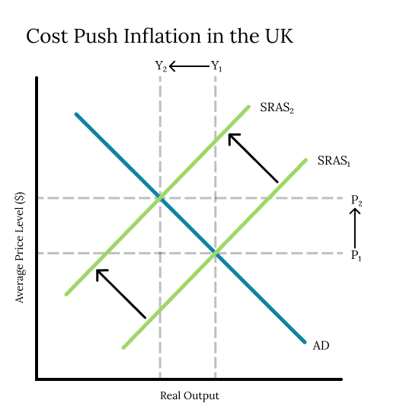

As indicated by the diagram, when the short run aggregate supply curve ([](https://www.codecogs.com/eqnedit.php?latex=SRAS_1#0)), moves to [](https://www.codecogs.com/eqnedit.php?latex=SRAS_2#0), a new equilibrium point is established in the economy. The average price level rises from [](https://www.codecogs.com/eqnedit.php?latex=P_1#0) to [](https://www.codecogs.com/eqnedit.php?latex=P_2#0) while the level of output falls from [](https://www.codecogs.com/eqnedit.php?latex=Y_1#0) to [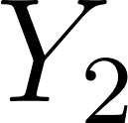](https://www.codecogs.com/eqnedit.php?latex=Y_2#0). As inflation is the increase in average price level, this causes inflation.

Other than representing a failure in a macroeconomic goal, inflation has many detrimental effects on an economy. One of the largest, as mentioned by the article, is the loss of purchasing power. If income rates do not rise at the same rate as the average price level, then consumers will experience a fall in **real income** (income adjusted for inflation). As a result of this, consumers will not be able to purchase the same amount or the same quality of goods and services that they could before. This loss of purchasing power can also lead to effects like labor unrest, which can further hinder real output.

Some of the most effective methods for fighting inflation arise from **intervention** from the government or the central bank. There are two main courses of action to remedy this inflation in the UK economy. The government could intervene, implementing a contractionary **fiscal** (relating to government revenue and spending) policy, or the central bank could intervene, implementing a contractionary **monetary** (relating to money or currency) policy. As mentioned in the article, the Bank of England is expected to gradually raise interest rates to 2.0 to 2.25% from 0.75% over the next year.

This is an example of contractionary monetary policy. The goal of this policy is to reduce the level of aggregate demand in the economy, which will shift the macroeconomic equilibrium to a point at a lower average price level.

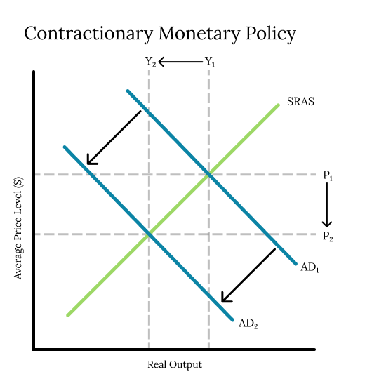

This is shown in the diagram, where the movement of the aggregate demand curve from [](https://www.codecogs.com/eqnedit.php?latex=AD_1#0) to [](https://www.codecogs.com/eqnedit.php?latex=AD_2#0) results in a fall in the average price level from [](https://www.codecogs.com/eqnedit.php?latex=P_1#0) to [](https://www.codecogs.com/eqnedit.php?latex=P_2#0). This would effectively reduce the average price level, counteracting the inflation.

While this would effectively lower the average price level and reduce inflation, there are some possible negative consequences to this solution. Higher interest rates can disproportionately affect those who have taken out loans or mortgages. Mortgage and loan payments will be higher, giving these people less real income. This monetary policy could also discourage borrowing by firms which could harm the economy in the long run.

Another possible course of action to reduce the average price level is through government **intervention**, specifically by raising income taxes on consumers. This would be an example of contractionary fiscal policy, which has the effect of lowering the amount of disposable income consumers have, as they have to pay a larger proportion of their income to the government. This in turn will lower the level of aggregate demand in the economy. This fiscal policy, much like contractionary monetary policy, will create a new intersection of the aggregate demand and short run aggregate supply curves at a lower price level.

There are significant downsides to this approach, however. Some of the biggest being time lags, as well as political pressure. In the UK, any changes to tax rates would have to pass through the democratic process, which means it will take a considerable amount of time to implement tax reform. In addition to that, measures that decrease consumers’ disposable income are generally unpopular, leading to possible further time lags and unhappiness.